**PROJECT DEVELOPMENT PHASE**

**SPRINT-4**

**CLOUDANT AND SMS**

|  |  |
| --- | --- |
| Date | 17 November 2022 |
| Team ID | PNT2022TMID12733 |
| Project Name | IoT Based Safety Gadget for Child Safety Monitoring and Notification |
| Maximum Marks | 1. Marks |

**AIM:**

To create cloudant database in IBM cloud and send alert message when the child is out of geofence through fast2sms.

**CLOUDANT:**

* Created database in IBM cloudant service as child_location_data.

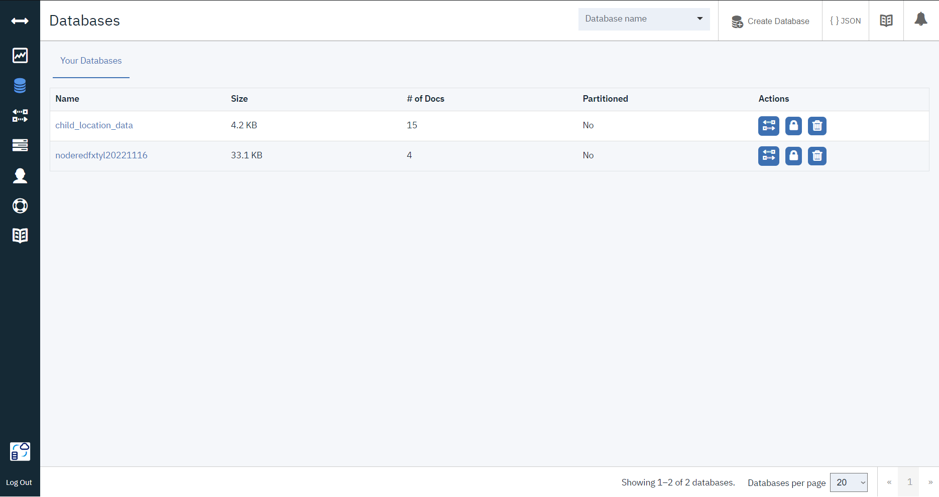

* Store the location coordinates in database

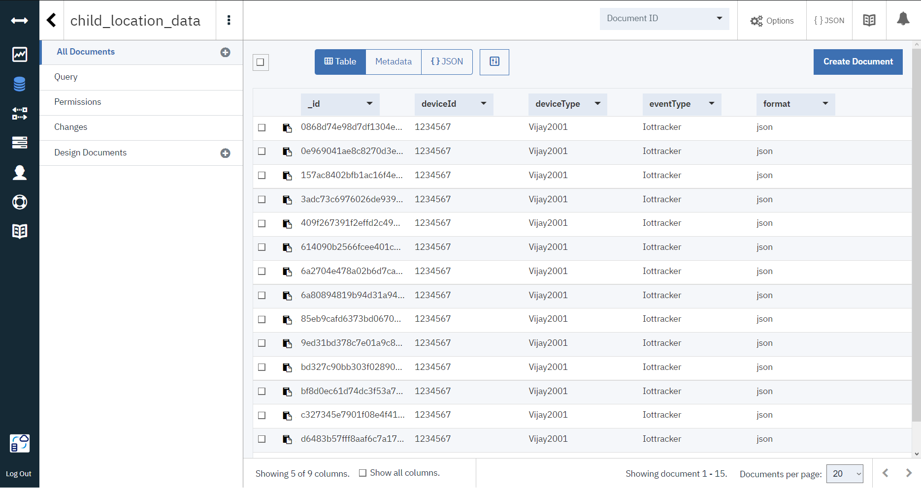

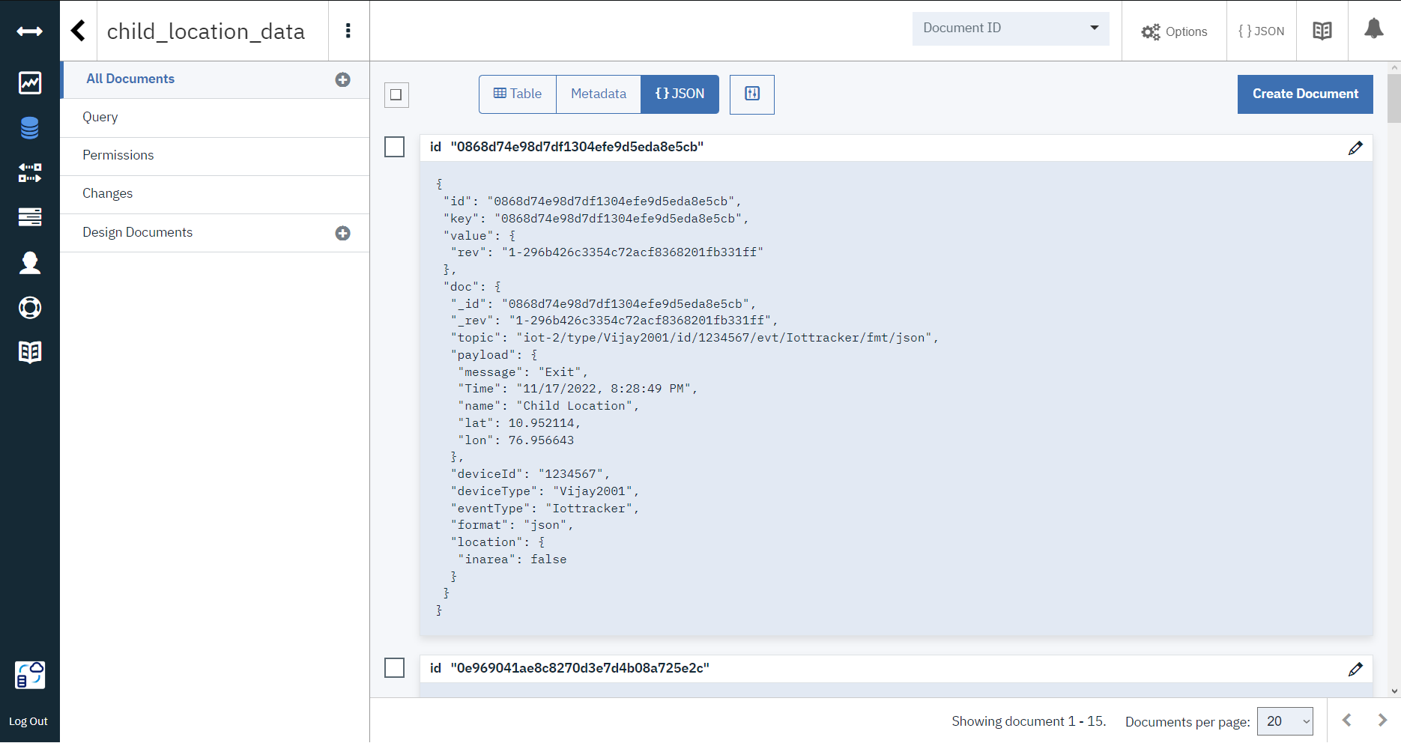

**ALERT SMS:**

* Created Dev API ULR to send message through Fast2sms services.

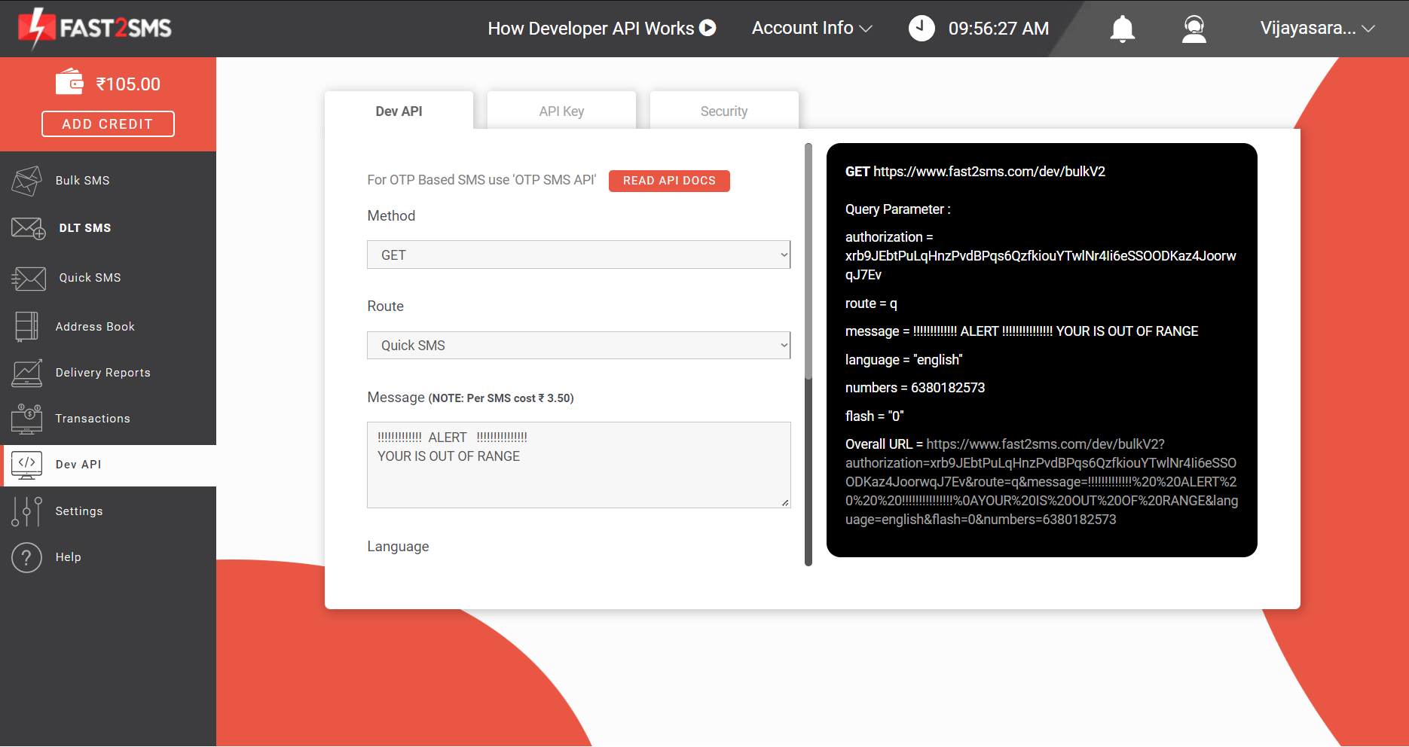

* Paste the url in http request node in node red.

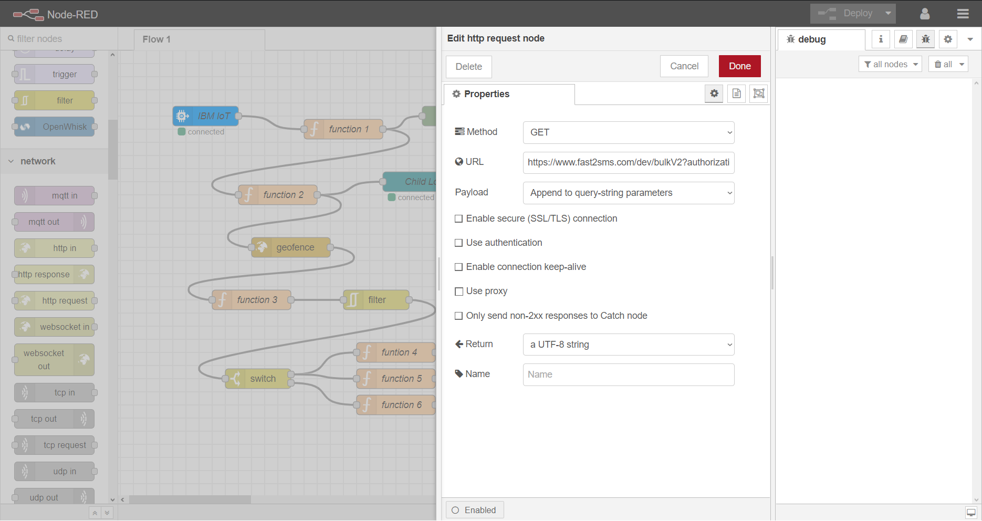

**SMS RECEIVED TO MOBILE PHONE:**

